Huntkey Launches Whole Line-up of 80PLUS Certified PSUs -- JUMPER Series; New Forward Circuit Design Brings More Stability and Higher Efficiency

Huntkey Enterprise Group launches a series of brand-new, structure design power supply units from 350W to 600W that are dedicated to mainstream users worldwide -- called JUMPER. All have passed 80PLUS or 80PLUS bronze certification. "Forward Circuit design brings more stability and higher efficiency to your system," said Villa Li, Huntkey Product Manager.

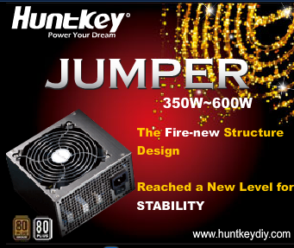

Considering environmental protection efforts to prevent global warming, more and more electronic devices manufacturers undertake big efforts to improve product efficiency in order to reduce power consumption as much as possible. Not only developed countries have realized the importance of high efficiency, but also many developing countries are now laying down laws to restrict energy-wasting electronic devices.

In the PSU field, "80PLUS" certification is the recognized evaluation criteria for energy efficiency worldwide. It comprises FIVE different levels, including "Platinum," "Gold," "Silver," "Bronze" and "Standard," depending on different efficiency levels. Take 80PLUS Standard for example; its efficiency must be no less than 80% from 20% to 100% load, which means the power consumption is only 20%. 80PLUS Platinum is the highest level which is dedicated to special PSU areas such as server PSU.

As one of the largest PSU manufacturers in the world, Huntkey launched its first 80PLUS PSU as early as 2007. Three years have now passed, and the technologies have become more mature, causing the production costs to reduce to a more acceptable range. Huntkey launches a whole range of 80PLUS products from Gold level to Standard level one by one. "Devoting ourselves to combining environment protection concepts with most end-users' actual needs is what Huntkey concerns itself with," said Alva Li, Global Marketing Manager said. "JUMPER series PSU is what Huntkey dedicates for mainstream users."

Rated power 350W, 400W, 450W, 550W, 600W comprise Huntkey JUMPER Series，which complies with Intel ATX12V V2.31 (SSI EPS12V V2.92 for JUMPER 550) providing the best compatibility with the most updated Multi-Core CPUs and supporting SLI & Crossfire multi-GPU VGA cards. They are certified by 80PLUS. JUMPER 450B and JUMPER 600B reach 80PLUS Bronze level. The input voltages from 100V to 240V ensure their worldwide usage.

Huntkey JUMPER power supplies are power supplies with a reasonable price and can be afforded by common users.

For more detailed information, please visit www.huntkeydiy.com

About Huntkey
Huntkey Enterprise Group, one of the top 5 power supply providers, founded in 1992, is a professional provider specialized in the development, design, manufacturing and marketing of power supplies. The products of Huntkey cover a wide variety, including power supplies (1W~250KW), power systems, computer cases, universal notebook adapters, chargers, power supply converters, power strip etc. The industrial parks of Huntkey in Shenzhen, Heyuan and Hefei, which cover a total area of over 750,000 square meters, are now the largest IT manufacturing base in China’s mainland. Huntkey with over 7,000 employees has set up its branch companies in Hong Kong, Japan and Europe. Its clients are found all over the world in more than 30 countries and regions, including Lenovo, DELL, etc.

